When you’re about to be ordained you get lots of cards and quite a few presents. A friend gave me a notebook to write my sermons in. Someone else gave me a lovely icon. My son made me a clerical collar out of black and white card, so I could always whip it out and wear it in an emergency.

One very good friend gave me this:

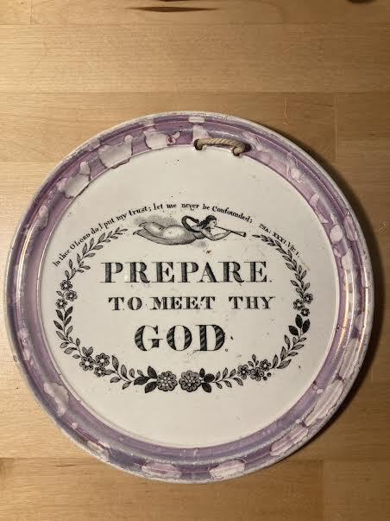

Well, of course it was a joke.

It’s the sort of thing we might expect a prophet to say. Someone like Jeremiah, or Hosea, or even John the Baptist. In fact, it’s a verse from the book of the prophet Amos, which we’ve been reading and discussing at Morning Prayer. It made us think of the sandwich board men who used to walk Oxford Street, handing out tracts. As they walked past, you’d glimpse the other side which read ‘Repent! The End of the World is Nigh’. I’m not sure they were ever very successful in gathering repentant souls, even in the mid 1980s. I’m certain that this hellfire and damnation approach is even further away from achieving a prophet’s aims today.

So what would a prophet be aiming to do today? What they’ve always done: to wake us up to injustice, to help us to see the calamity that we have made for ourselves out of the beautiful creation we have been placed in, to help us to see that the path to abundant life comes from living differently, according to the pattern of Christ, our window into God’s love and justice. To help us to be what God wants us to be. To help us to ‘do justice, and to love kindness and to walk humbly with our God’, as Micah would have it.

It seems to me that our Old Testament reading, and the Gospel together point us in a different direction from that of the fire and brimstone prophets, and the sandwich board preachers. The message to get across is the same: ‘Repent’, or literally ‘turn around’ as individuals, as communities, as churches, as nations. Surely the devastating effects of this pandemic are making us long for change! But how on earth are we going to get people to listen to us as individual Christians, or as the church?

First, before we can speak, we need to listen ourselves. Here, the story of the boy Samuel has something to teach us. In Hebrew his name is something softer: Shmuel. Imagine lying on a mat in the half darkness and hearing that whispered: Shmuel, Shmuel. Would our ears be sharp enough to listen to a sound that could be the breeze blowing around outside? The word of God needs listening for. And who is doing the listening here, discerning what God wants to say? The child, who’s perhaps just the servant boy who helps the aging, partially sighted Eli with his daily tasks. Oh, and like today, no one is expecting God to speak. That doesn’t seem to have happened in a very long time. Listening to unfamiliar people, in places where we’re not expecting God. If we sharpen our ears will we hear?

We have experience here at St James’s in listening to unfamiliar people in places we’re not used to meeting God. You did a year of it before I arrived as your Curate, as you interviewed people who live near us who aren’t members of the congregation, for Partnership for Missional Church. One recent fruit of those encounters is the new sign outside the building. It was only through listening that we became aware that the unfamiliar people didn’t know our name. In a manner of speaking, we hadn’t introduced ourselves.

Second, we can’t leave it at listening. At some point we’re going to have to speak, or even act. Strangely enough, nowadays it can sometimes feel harder to speak in a way that enables others to really hear us, than to act.

The plaque I was given was probably made in a pottery in Sunderland in the first half of the 19th Century. Cornfoot, Colville and Company turned out thousands of these plaques, and other potteries in the area used the same transfer design throughout the century. Amos’s verse was the most popular of all their religious designs. Imagine how many houses would have had a plaque like this on the wall. But my friend didn’t have the serious intent of those who first bought and displayed it. As I’ve said, he gave it to me as an ironic joke. The words don’t speak to us today in the same way they did two hundred years ago.

I wonder how Samuel spoke to Eli, so that Eli was able to accept such a tough message from the mouth of a child. I’m reminded of the story of the Emperor who parades through town in nothing but his birthday suit, and only the child on his father’s shoulders will point out the obvious. Do you remember how, before Christmas, Steve’s reflection was on the Beatitudes from Matthew’s Gospel. He asked us to use our breakout group time to come up with some new Beatitudes for today. What a good way to think about speak truth in such a way that we can be heard afresh! The new Beatitude I recall best came from Marisa: ‘Blessed are the patient, for they shall be heard’. That is a life changing, church changing message for me. I know I’ll carry that prophetic message with me wherever I go.

Third, what about action?
I recently watched a talk on YouTube given by Sister Helen Prejean, the nun who wrote Dead Man Walking’ about her work with prisoners on Death Row in the USA. In passing she referred to Jesus’s comments about visiting those in prison. We have a habit of trying to spin the scriptures, she said. When she got to the words of Jesus in Matthew: ‘I was in prison and you visited me’, she thought she was being told that we’re all prisoners of something or other – imprisoned by our past, our sins, our shyness or whatever. ‘I never dreamed the words meant, “I was in prison and you came to me”’. That through these words Jesus was giving a pretty unambiguous pointer towards action.

Jesus is all about action. Look at what happens here, in today’s Gospel. ‘Come and see!’ Jesus says to two disciples of John the Baptist just the day before. Now, here he is, meeting Philip: ‘Follow me’, says Jesus and straightaway Philip does and finds cynical, worldly Nathaniel to join him, speaking Jesus’s own words to him: ‘Come and see’…and he does.

Sister Helen described the process of acting on the call from God, and it’s just like this.
‘it’s liberating to act, the hardest part is deciding whether to do this, or that’. What to do? ‘Just put your hand on the rope and start pulling, and Grace comes in and then reveals the next steps.’ It sounds so simple. And frightening. We have no idea where our actions will take us. Philip and Nathaniel had no idea, and nor did sister Helen. We can be sure, though, that if we do take the plunge and follow, we will see greater things done through the power of God’s grace than we can imagine.

Questions for breakout rooms
Who should we be listening to at the moment?
How can we speak so that God speaks through us?
Are you being called by God to act? What is God’s calling for our church?

